Blazor Hosting Models

1. Hosting Models in Blazor – Big Picture
Blazor is a Single Page Application (SPA) framework built on .NET that allows you to write client-side UI using C# and Razor instead of JavaScript.
Blazor supports following hosting models:
- Blazor Server
- Blazor WebAssembly (WASM)
- Blazor Hybrid (Blazor + .NET MAUI)
Each model differs mainly in:
- Where the code executes
- How UI events are processed
- How the browser communicates with .NET

2. Introduction to Blazor Server
What is Blazor Server?
Blazor Server runs all application code on the server.
The browser only renders HTML and sends UI events (clicks, inputs) back to the server.
Key Concept:
UI logic executes on the server, not in the browser.
How It Works
- User requests the application.
- Server sends a minimal HTML page.
- A persistent SignalR connection is established.
- UI events are sent to the server.
- Server processes events and sends DOM diffs back to the browser.
Characteristics
Aspect | Description
Execution | Server
Client requirement | Any modern browser
Download size | Very small
Initial load | Very fast
Internet dependency | Mandatory

3. Blazor Server Communication with SignalR
What is SignalR?
SignalR is a real-time communication framework in ASP.NET Core that enables bi-directional, persistent communication between a client (browser, mobile app) and a server.
Why SignalR?
Blazor Server uses SignalR to maintain a real-time, bi-directional connection between browser and server.
SignalR Responsibilities
- Tracks UI state per user
- Sends user events to server
- Sends UI updates (DOM diffs) to client
Advantages
- Centralized business logic
- Easy authentication & authorization
- Strong security (code never reaches client)
Challenges
- High concurrent users = high server memory
- Network latency affects UI responsiveness
- Not ideal for unreliable networks
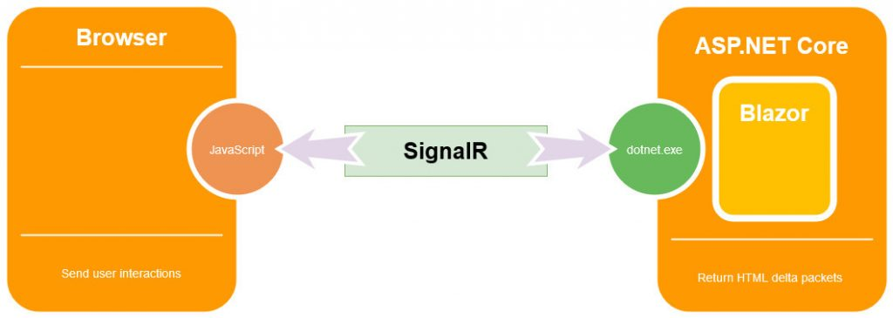

4. Introduction to Blazor WebAssembly
What is Blazor WebAssembly?
Blazor WebAssembly runs entirely in the browser using WebAssembly (WASM).
Key Concept:
Your .NET application is downloaded and executed inside the browser.
How It Works
- Browser downloads:
  - .NET runtime (WASM)
  - Application DLLs
- Application runs locally in browser sandbox
- UI logic executes client-side
- API calls are made using HTTP
Characteristics
Aspect | Description
Execution | Browser
Download size | Large
Initial load | Slower
Offline support | Possible
Server load | Low
Scalability | Excellent

5. Blazor WebAssembly Communication Using WebAssembly
Communication Model
Blazor WASM does not use SignalR by default.
Instead, it uses:
- HttpClient
- REST APIs
- gRPC (with limitations)
- JavaScript Interop
Execution Flow
- User interacts with UI
- C# code runs inside browser
- API calls are sent to backend services
- Responses update UI locally
Browser Sandbox Constraints
- No direct file system access
- No direct OS access
- Limited threading
- Depends on browser security model

6. Blazor WebAssembly vs Blazor Server
Comparison Table
Feature | Blazor Server | Blazor WebAssembly
Execution | Server | Browser
Initial Load | Very fast | Slower
Runtime Location | Server | Client
Internet | Required | Optional
Scalability | Moderate | High
Security | Strong | Code exposed
Offline | Not supported | Supported
Hosting Cost | Higher | Lower

When to Choose What?
Choose Blazor Server when:
- Enterprise internal apps
- Real-time dashboards
- Strong security requirements
- Fast development & low client constraints
Choose Blazor WebAssembly when:
- Public-facing applications
- Offline support required
- High scalability needed
- Client-heavy interactions

7. Blazor Hybrid / .NET MAUI
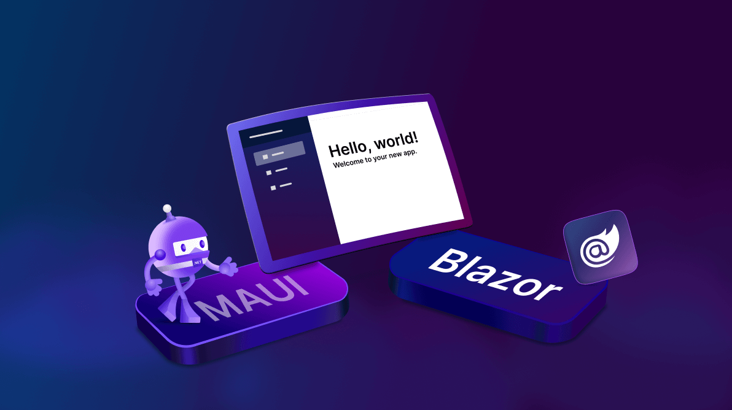
What is Blazor Hybrid?
Blazor Hybrid embeds Blazor UI inside native applications using .NET MAUI(Multi platform App UI).
Supported platforms:
- Windows
- macOS
- Android
- iOS
Typical Use Cases
- Enterprise desktop applications
- Mobile apps with shared web UI
- Line-of-business tools
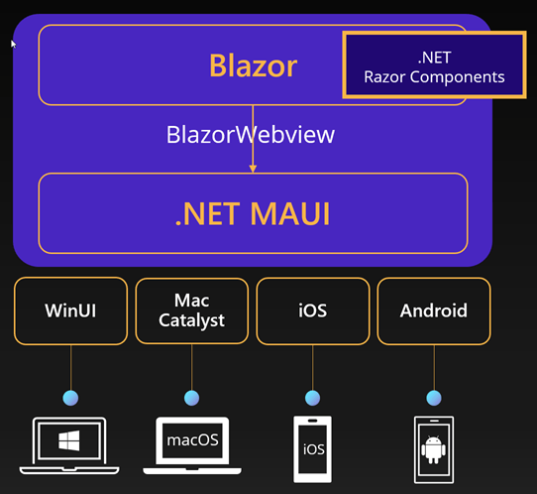

8. Summary – Choosing the Right Hosting Model
Scenario | Recommended Model
Internal enterprise apps | Blazor Server
Public SPA with scale | Blazor WebAssembly
Offline-first apps | Blazor WebAssembly
Desktop & mobile apps | Blazor Hybrid
Real-time collaboration | Blazor Server

Final Note
Blazor hosting models are not competitors, but strategic options.
Modern architectures often combine models:
- Blazor WASM frontend
- ASP.NET Core Web API backend
- SignalR for selective real-time features
- Blazor Hybrid for companion desktop/mobile apps

